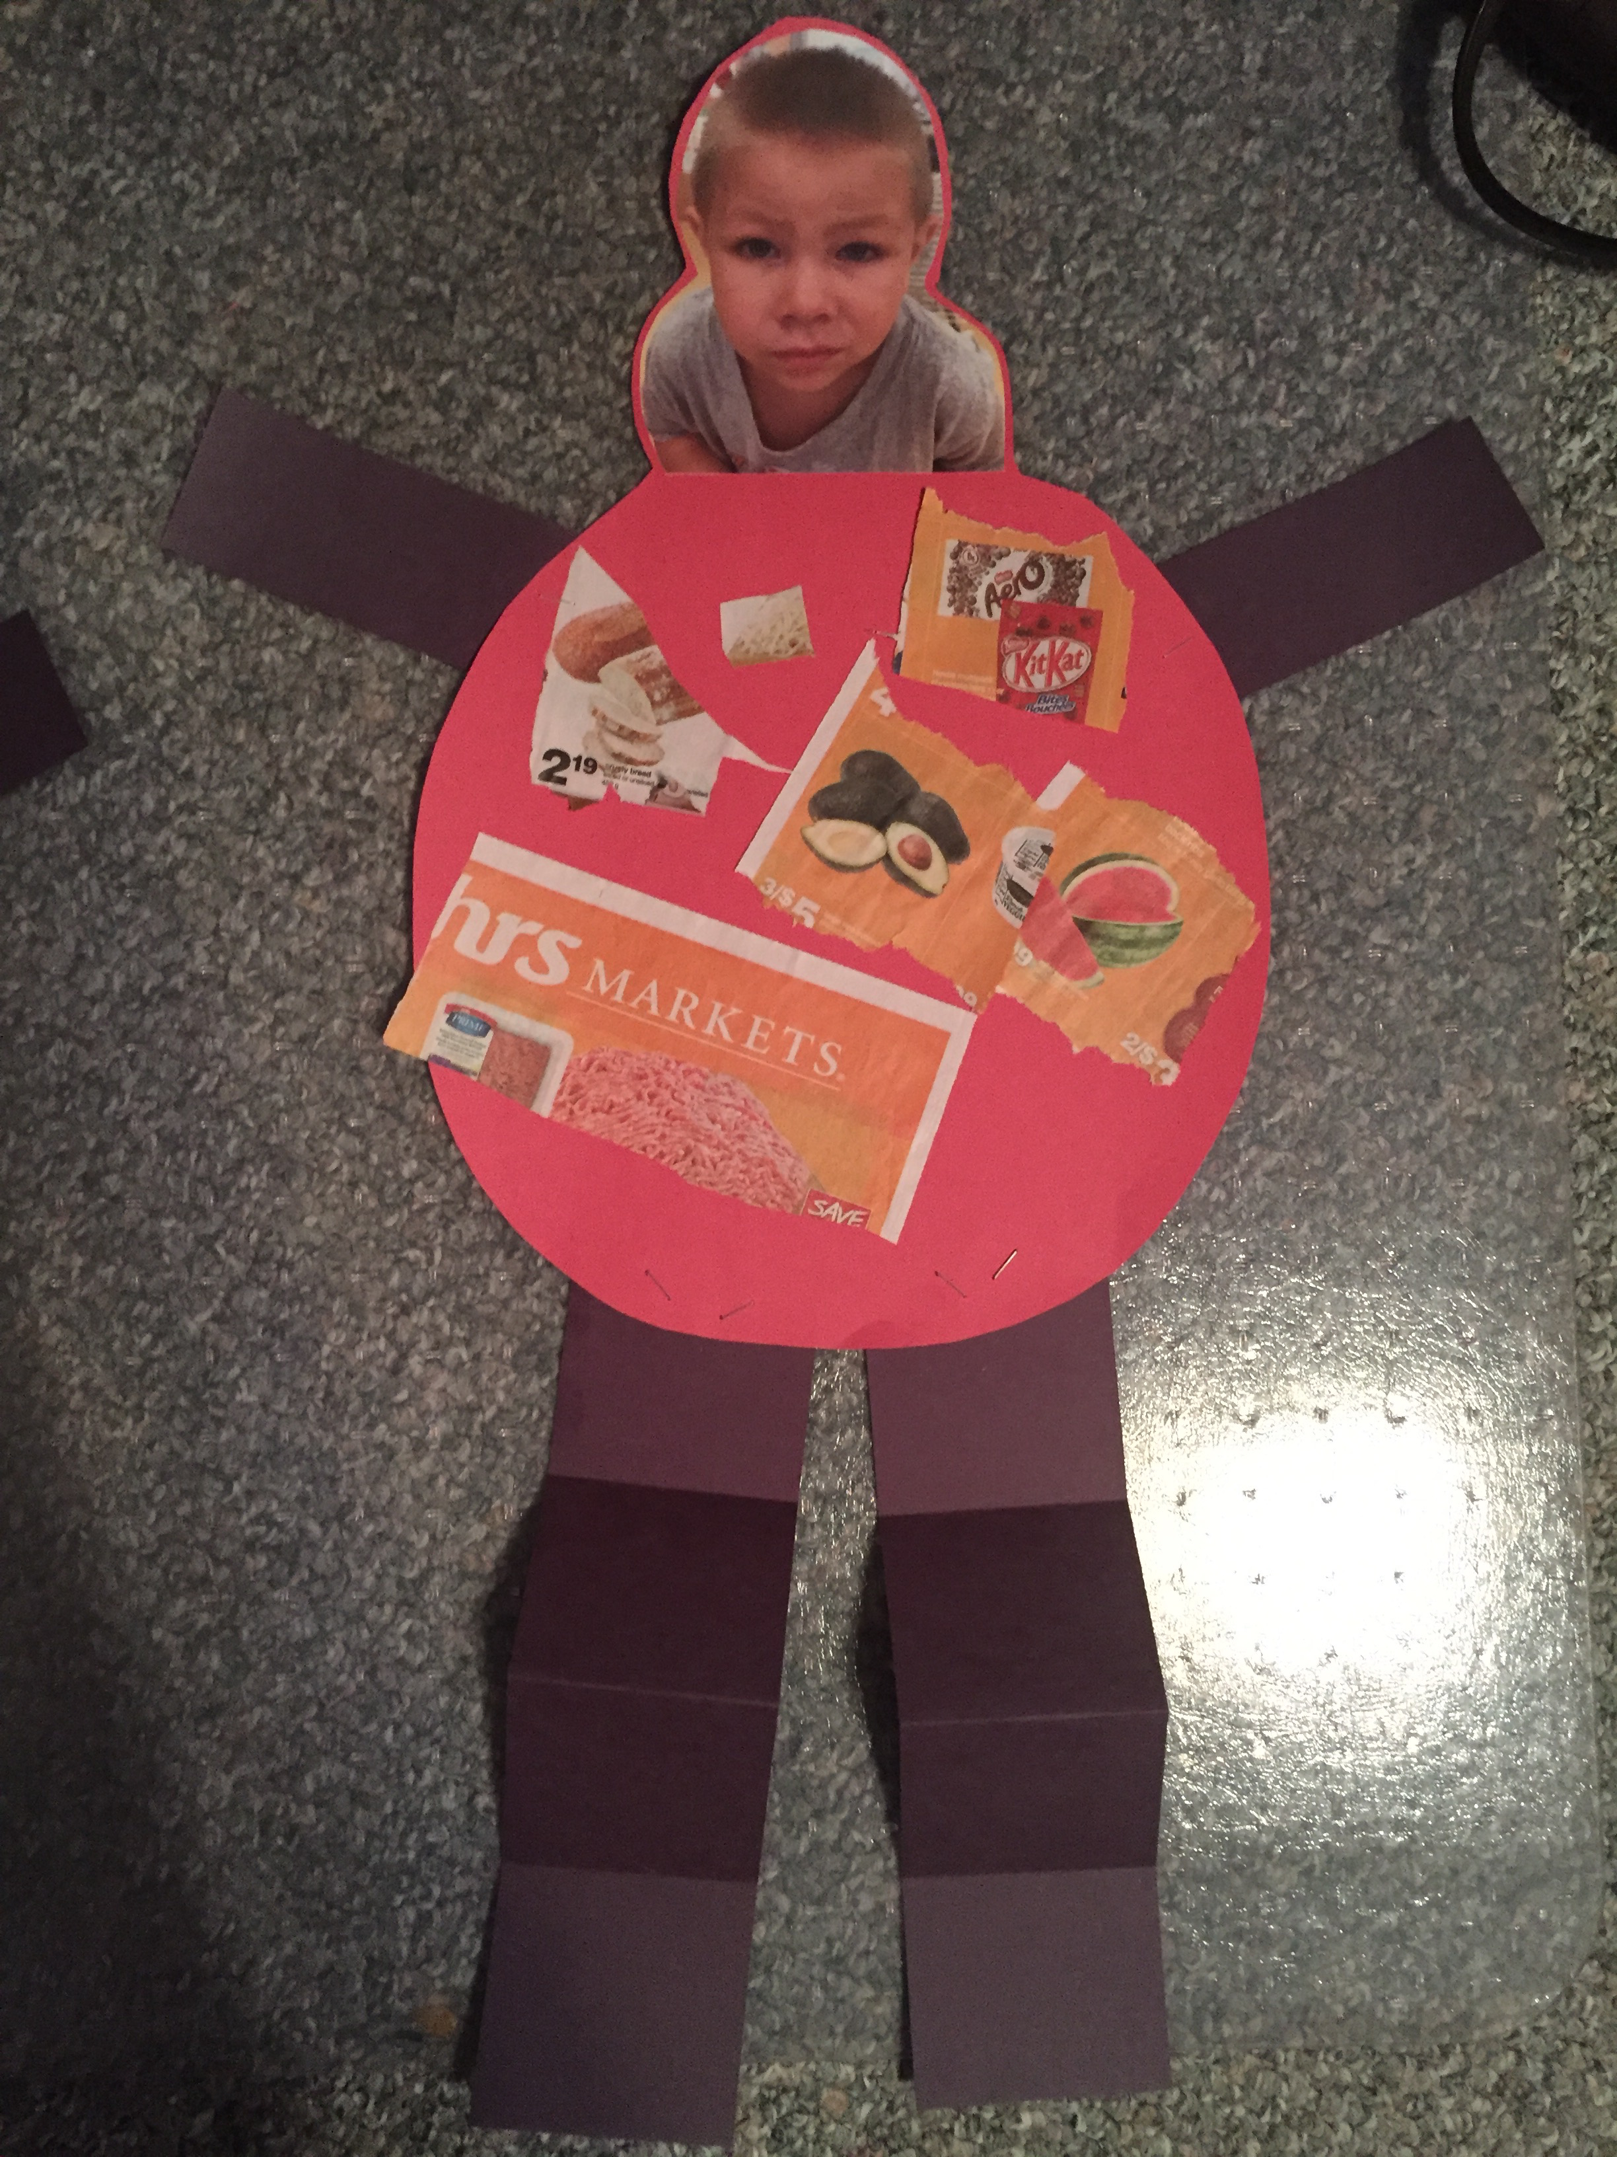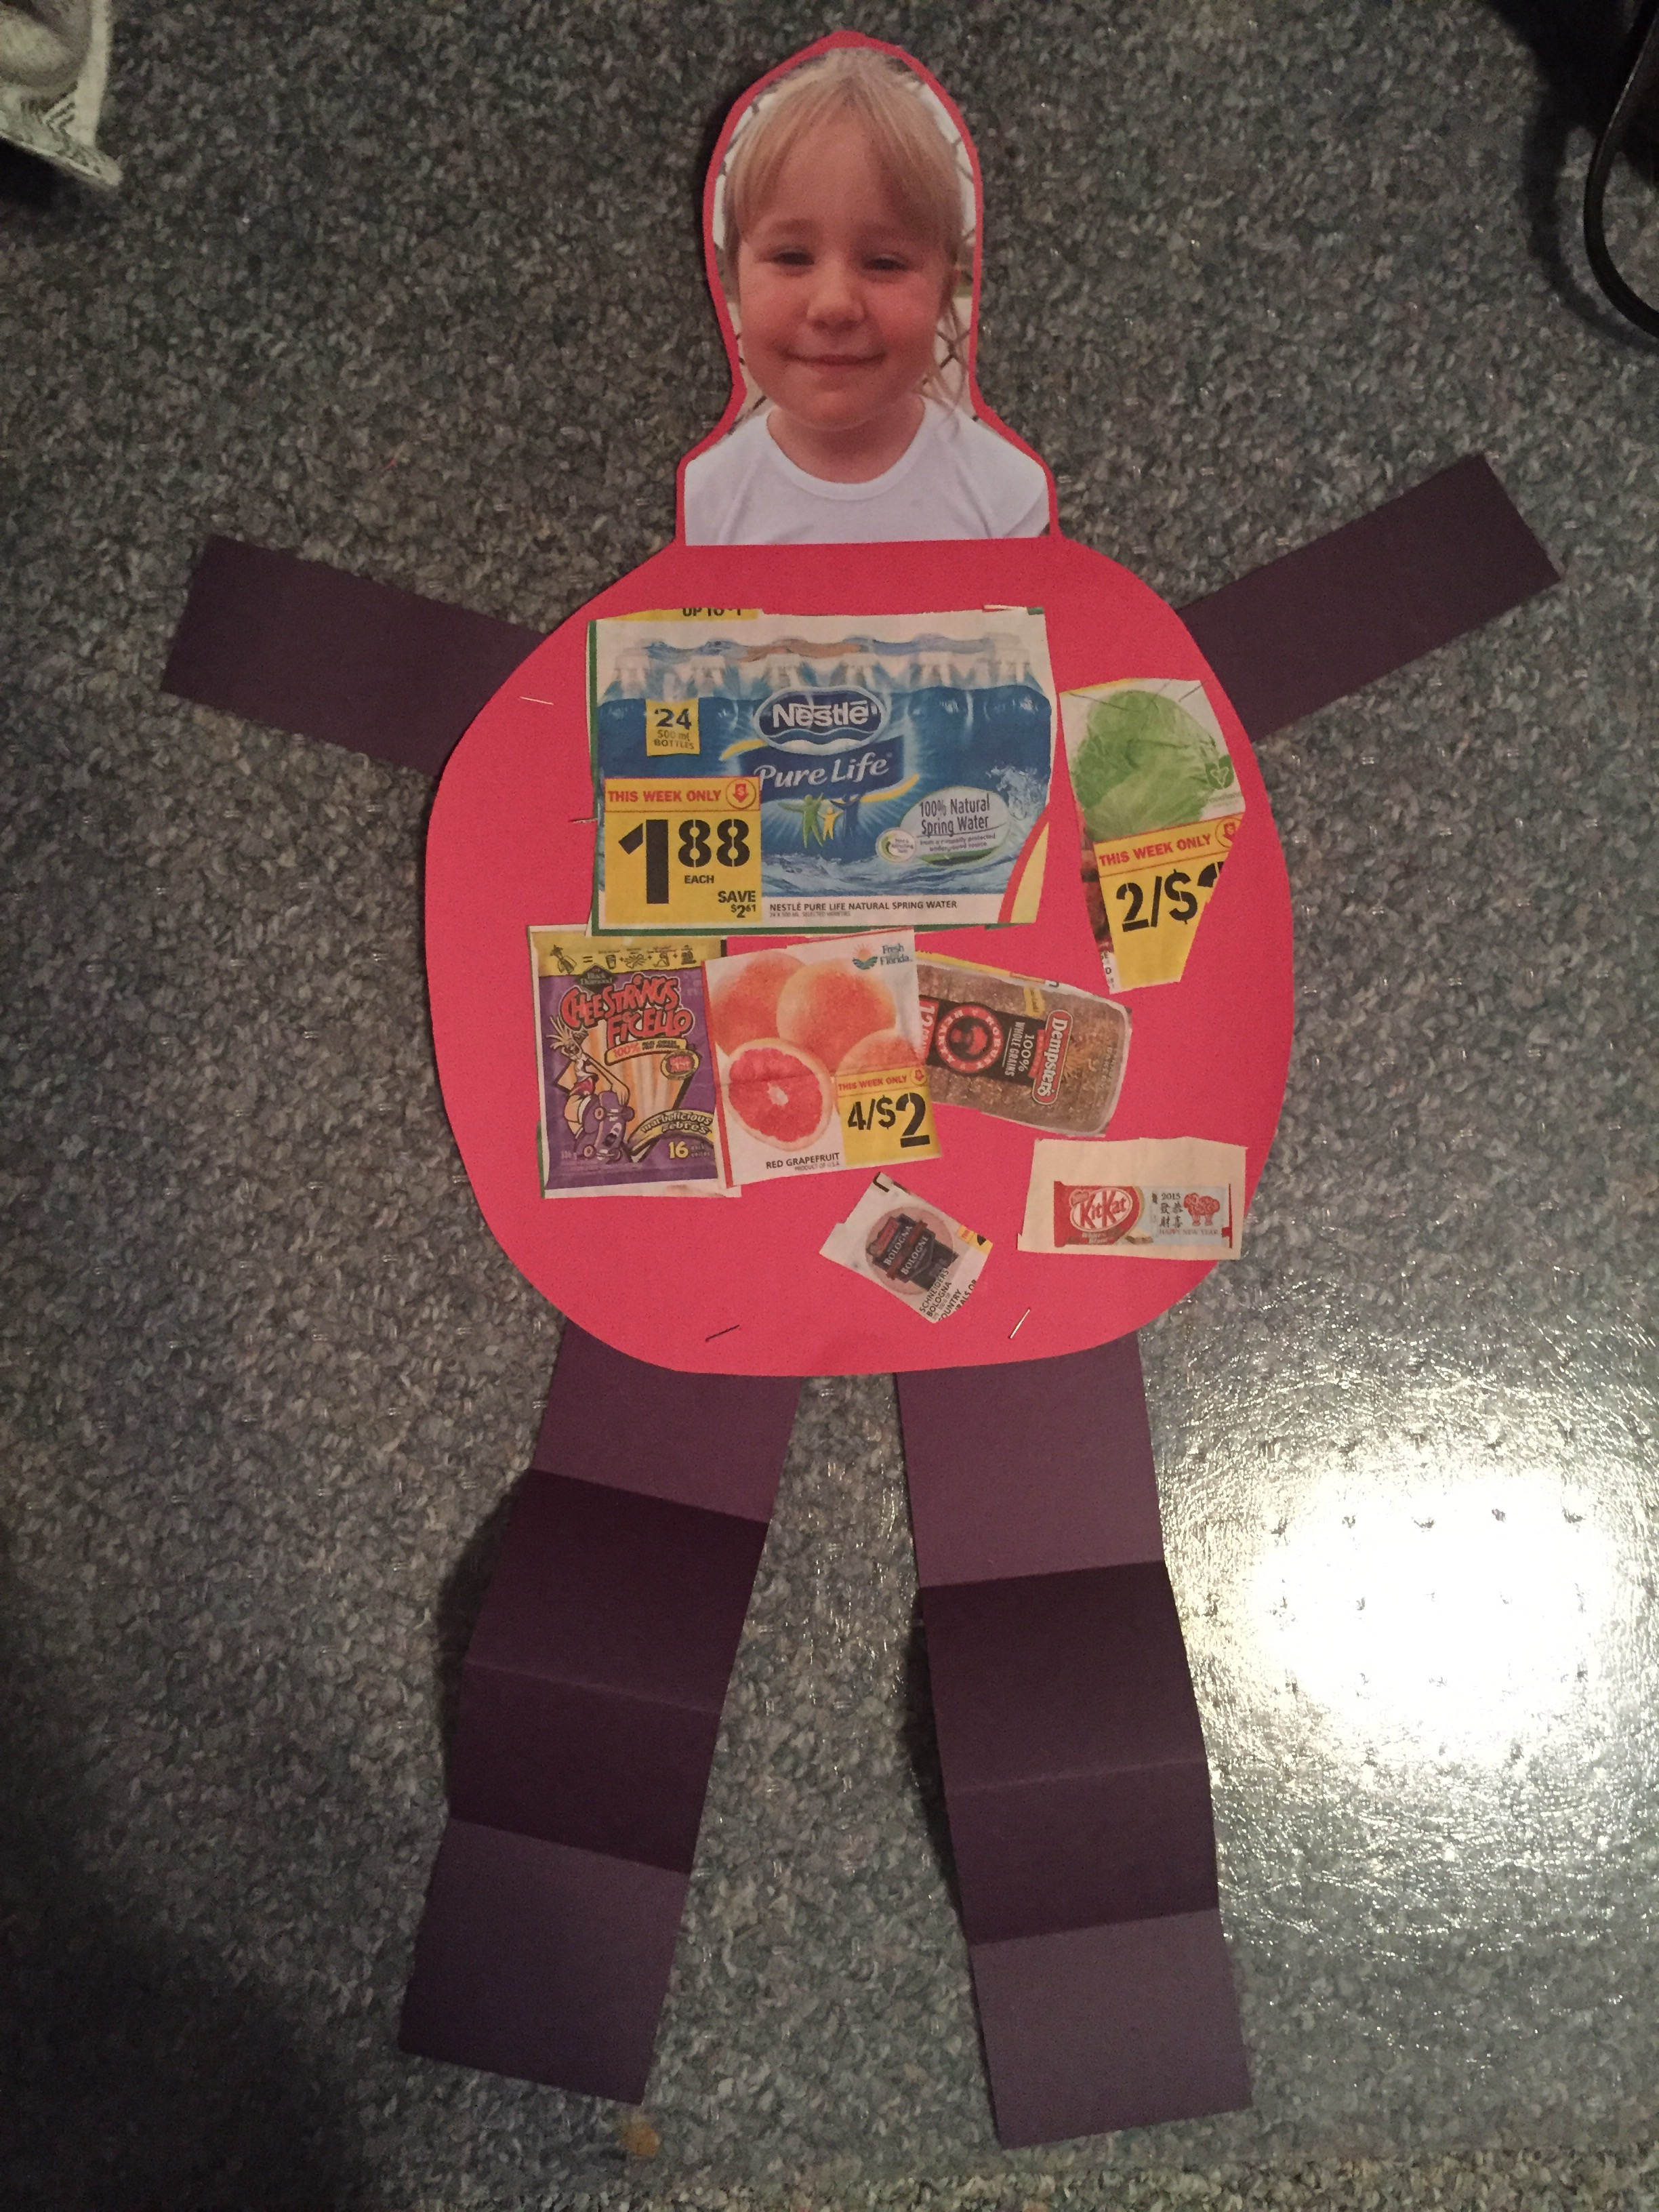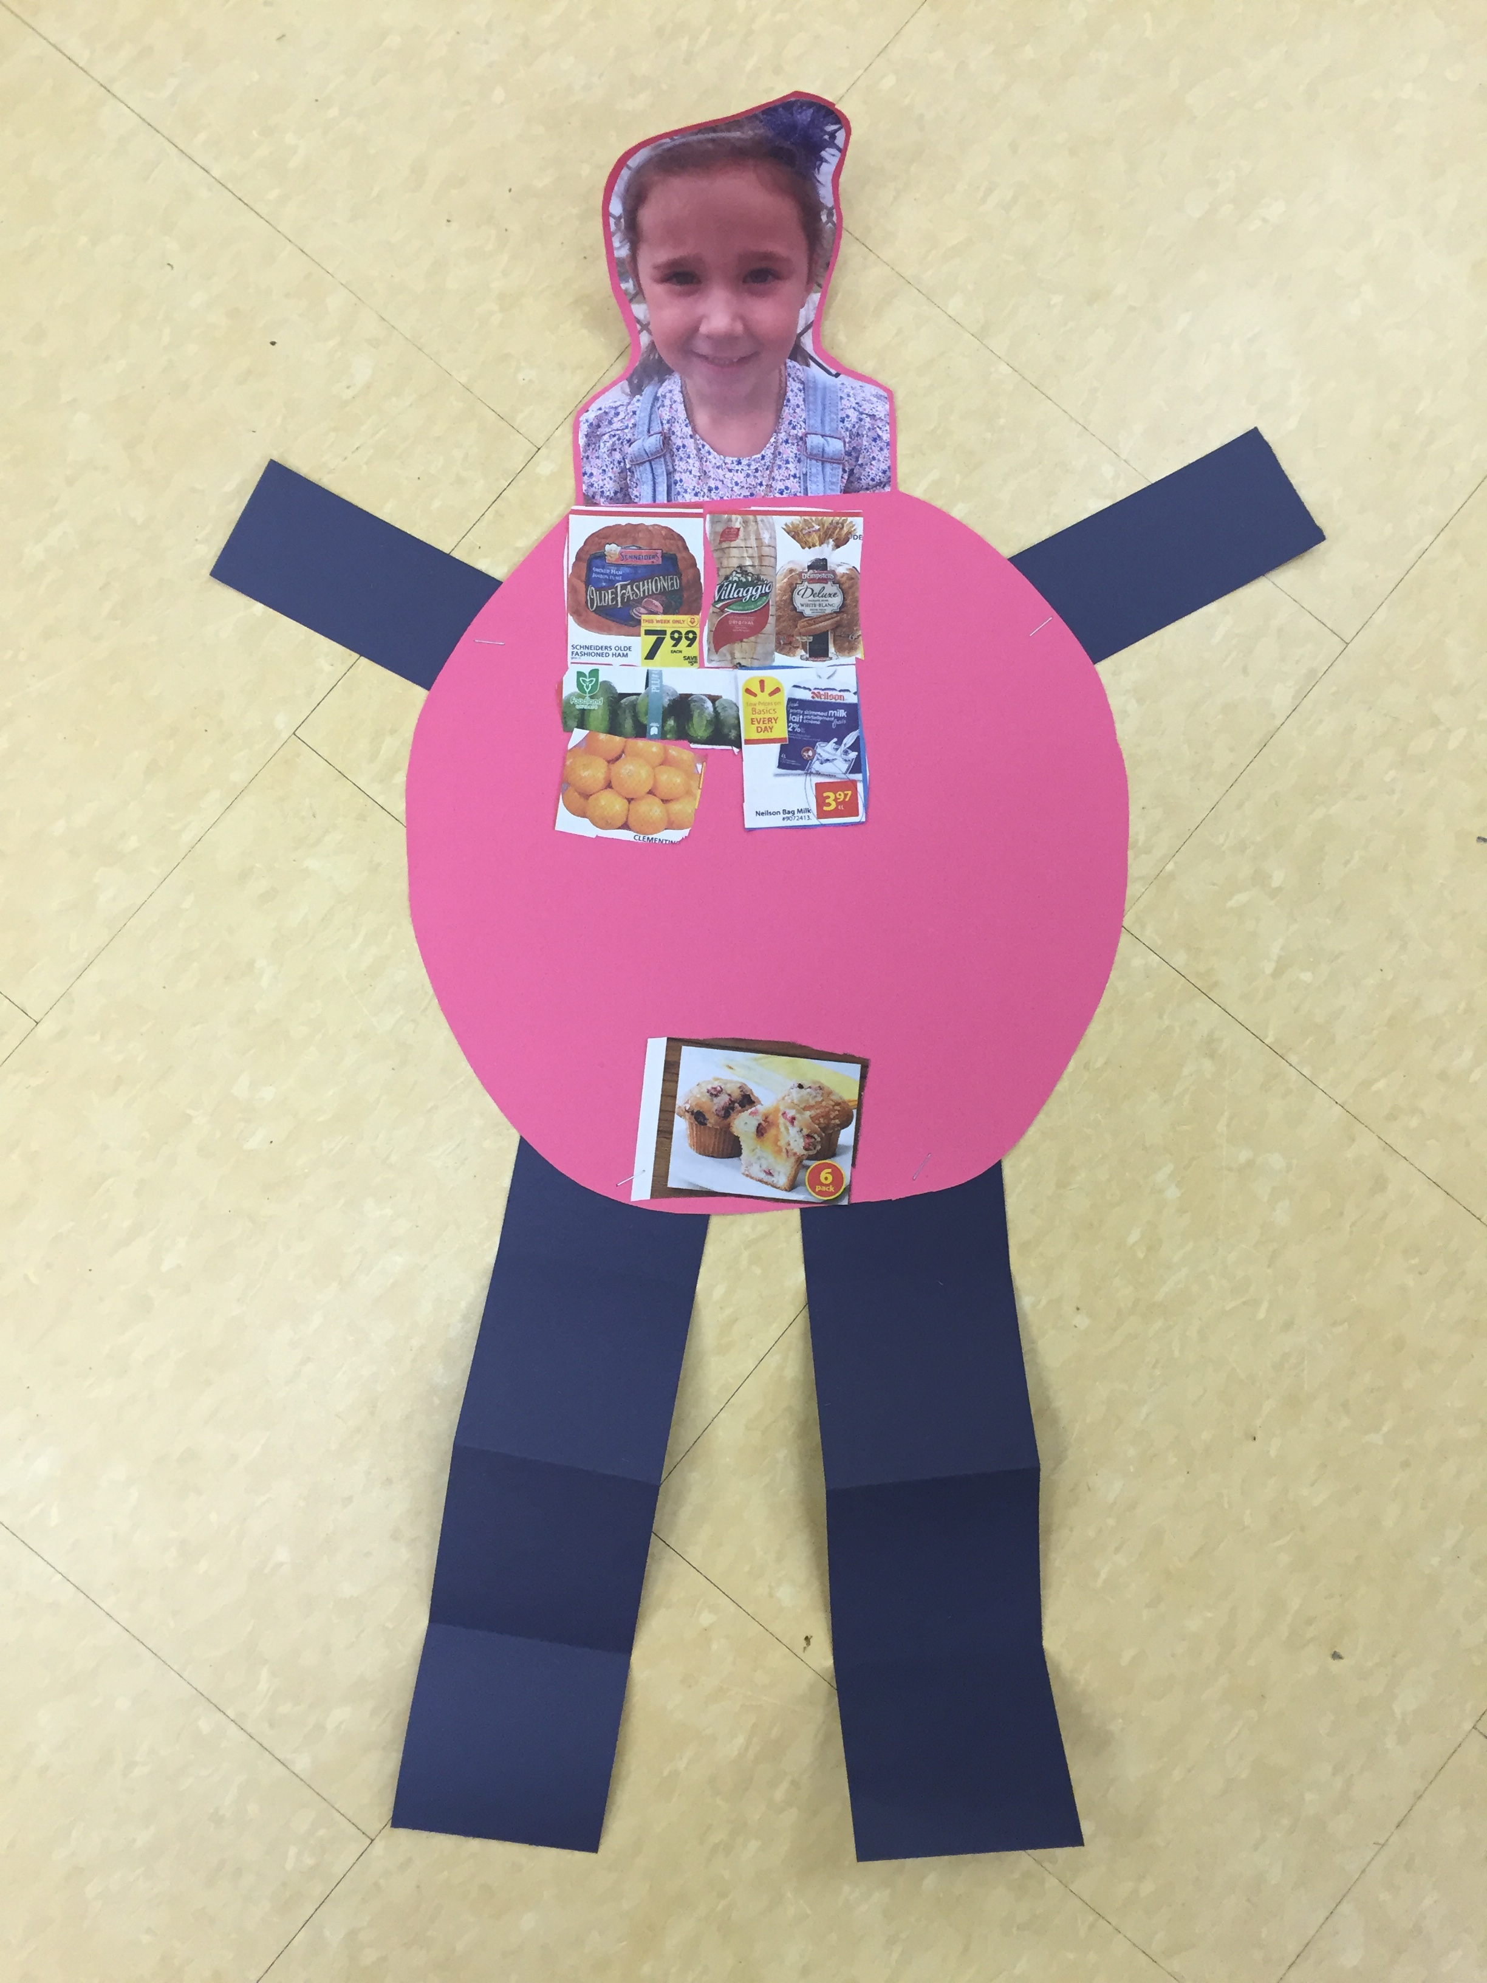

After our week of learning about healthy eating, we read the story *I Knew An Old Lady That Swallowed a Pie,* and talked about the foods that she ate in the story. In the story, the old lady is HUGE by the end of the book.

We decided to make ourselves after we are full of healthy foods.

**Success Criteria:**

* I have included at least 1 food from each of the five food groups
  + Vegetable
  + Fruit
  + Grain
  + Meat
  + Dairy
* I have included 1 unhealthy food as a dessert

**I Knew An Old Lady**